POC (PROOF OF CONCEPT) PROJECT

V 3 Main

PIPELINE DESIGN
SPECIFICATION (DRUPAL)

January 23rd, 2022
Submitted By

Satya B
Project Manager
POC V 3 Main Project

Table of Contents
Table of Contents ii
Revision History iii
Approved By iii
1. Introduction 1
1.1 Purpose 1
1.2 System Overview 1
1.3 Design Map 1
1.4 Definitions and Acronyms 2
2. Design Considerations 2
2.1 System Environment 2
3. Architecture 2
3.1 Create Docker image and Test in client environment 3
3.2 Deploy Docker image to Docker Hub using Jenkins 6
3.3 Deploy Docker image to Kubernet Cluster using Jenkins 9
4. Source Code and Cred details 11
4.1 GitHub 11
4.2 Jenkins 11
4.3 Docker 11
4.4 MYSQL 11
4.5 Clear Cache...............................................................................................................11

Revision History
Version | Name | Reason For Changes | Date
1.0 | Peeyush Jaiswal & Sai Prakash | Initial Revision | 05/01/2022
2.0 | Peeyush Jaiswal & Satya B | Minor Format Changes and Verbiage | 22/01/2022

Approved By
Approvals should be obtained for project manager, and all developers working on the project.

Name | Signature | Department | Date
Satya B | Reviewed & Approved | Gradient M Project Team | 22/01/2022

Introduction

Purpose
This design will detail the implementation of the requirements which helps customer to deploy open source CMS like Drupal on Kubernetes cluster using CI/CD pipeline – CI/CD Pipeline Workflow – POC.

System Overview
This project is intended to perform a POC for the customer to design a automated CI/CD pipeline. This platform will have container which performs to run open source PHP based CMS application like Drupal 9.x edition under the customer development environment Windows/Linux red hat.

Design Map
Summary contained in this document helps customer to understand the CI/CD and build process. This contains multiple phases, and each phase has details explanation about pipeline job so that customer can integrate this within his current system. A high-level CI/CD workflow:

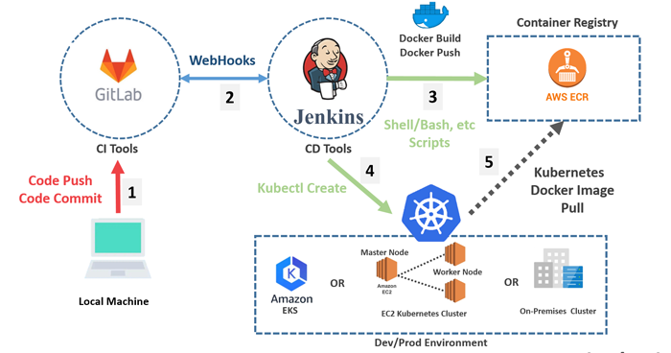
High Level CI/CD Diagram

Definitions and Acronyms
POC – Proof of concept.
CMS – Content management system.
CI/CD – Continuous integration and continuous deployment
Deployment Files – Template used for kubernet cluster.
Host name – kubernet pod IP address or Local host Apache IP

Design Considerations
All design considerations were handled in CI/CD pipeline workflow release 1.

System Environment
The CI/CD Workflow process resides in the Jenkins server which deploy image to kubernet cluster application that resides on the client’s machine that has an Linux/Red hat operating system. POC is used for Open-source CMS like Drupal to automate build process. The database used to store the data will be on MYSQL Server. Template will be used as the Standard CI/CD design product.

Architecture
Please find the architecture diagram below which explain the process. This will have 3 steps to complete CI/CD architecture:

- Create Docker image and Test in Client environment
- Deploy Docker image to Docker Hub using Jenkins
- Push Docker image to Kubernet cluster using Jenkins

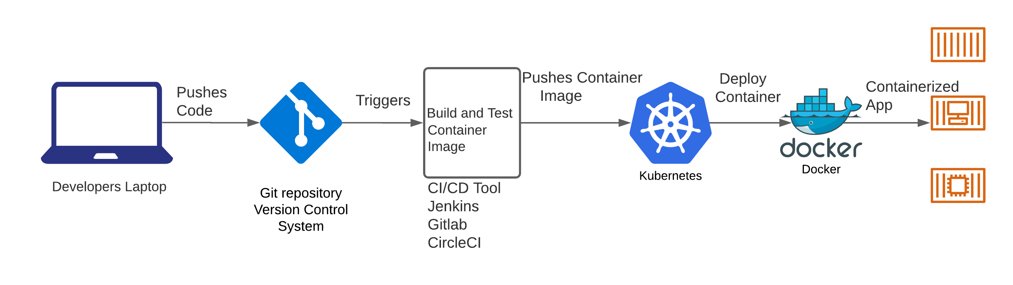
CI/CD Diagram

Create Docker image and Test in client environment
This step will have docker script to create environment to run Drupal(9.3), PHP(7.4) and Apache application. Script has Composer and Drush installed at run time to install dependency under /var/www/html/vender directory. Script will also have some Apache and PHP setting to enable which makes application to run properly.

To test Docker image locally :

- Clone the code from git hub or pull image from v3mainproducts/drupal

Commands:
git clone -b drupal_poc https://github.com/V3Main-Tech/drupal.git
OR
docker pull v3mainprodcuts/drupal:latest
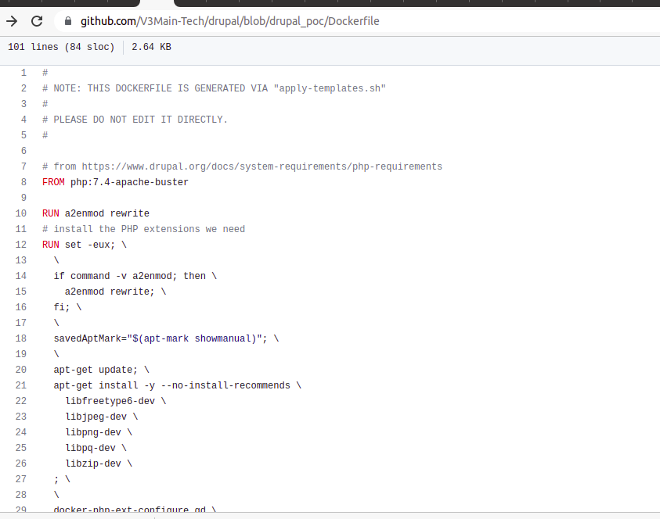

- Now go to the clone directory in local and try to run the docker compose command

Commands:
docker-compose up

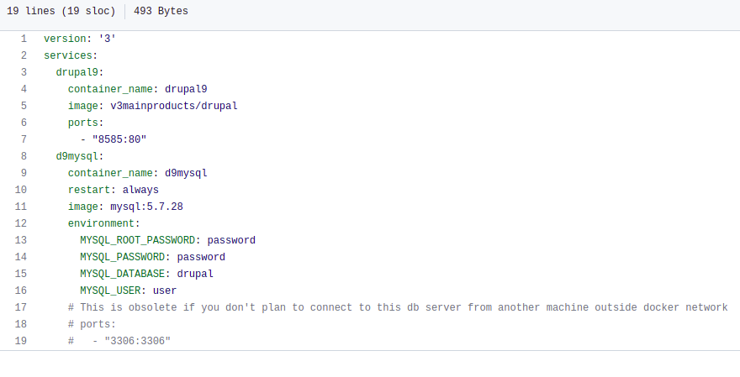
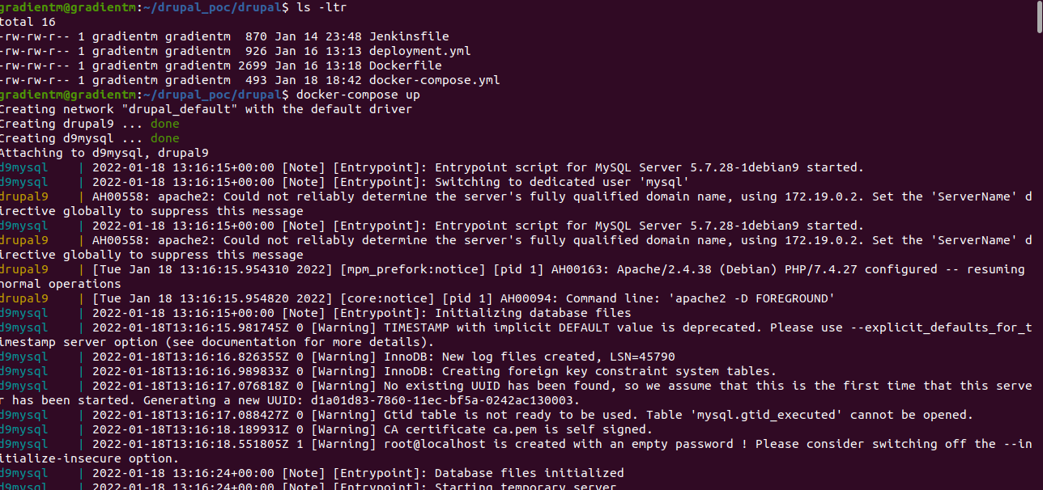

- Try to the see the output (above screenshot) Apache will show some IP address just copy and paste in web browser and attached with port :8080
Example: http://172.20.0.3:8080/

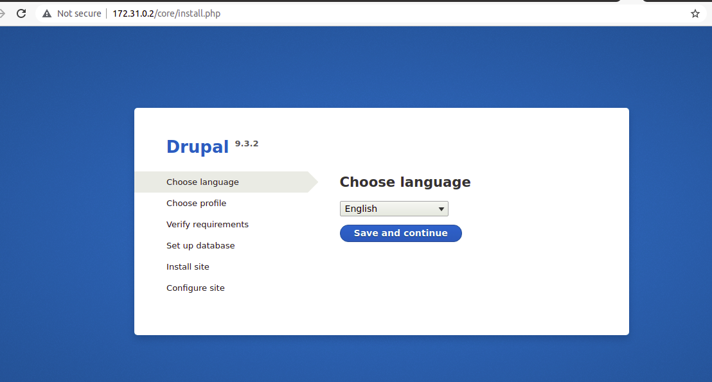

- Now click on continue button to provide Database information setting. Make sure provide container name in Host under advance option.
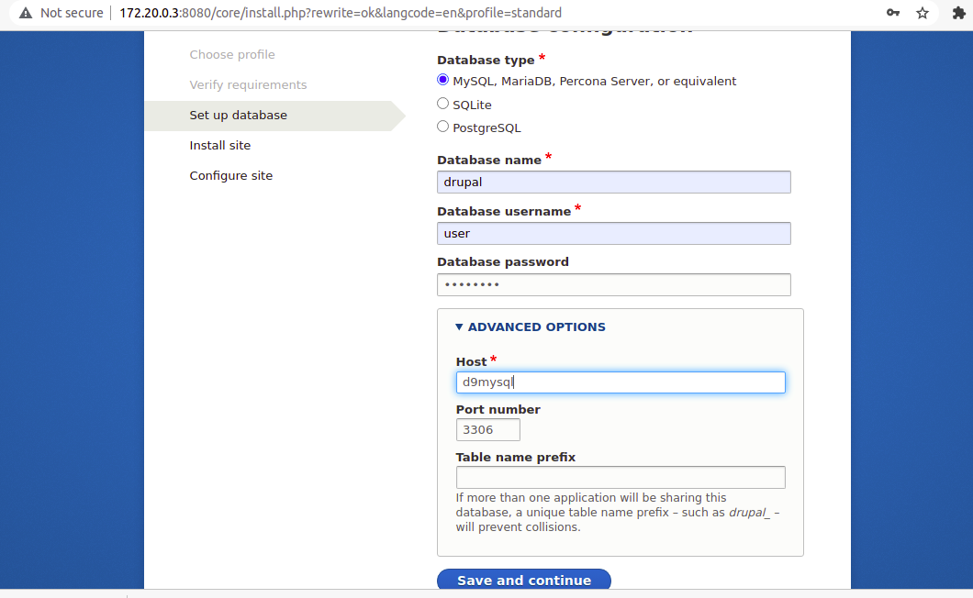

- After that click on next to install drupal.

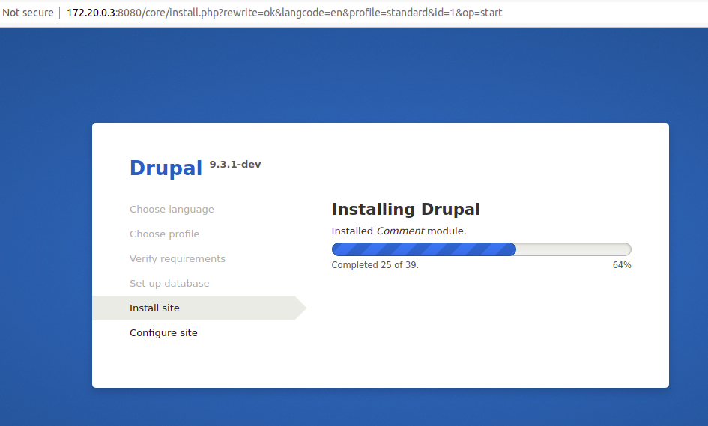

Deploy Docker image to Docker Hub using Jenkins
In this steps we will create image at run time and deploy to docker hub using Jenkins. You should have software installed and created credentials for the connection.

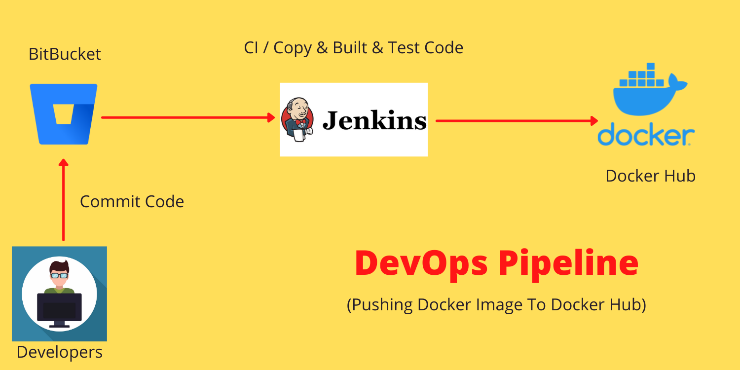
DevOps Pipeline Diagram

Pr-requisite:
- Jenkins server (installed on a cloud server)
- Docker to be installed on the same Jenkins server.
- GitHub account. (Branch name: drupal_poc)
- Docker Hub account (registry cred: ‘docker_hub_creds’, repo name: v3mainproducts/drupal)
First, we should have git hub and docker hub cred which will be used to make connection in Jenkins build job.

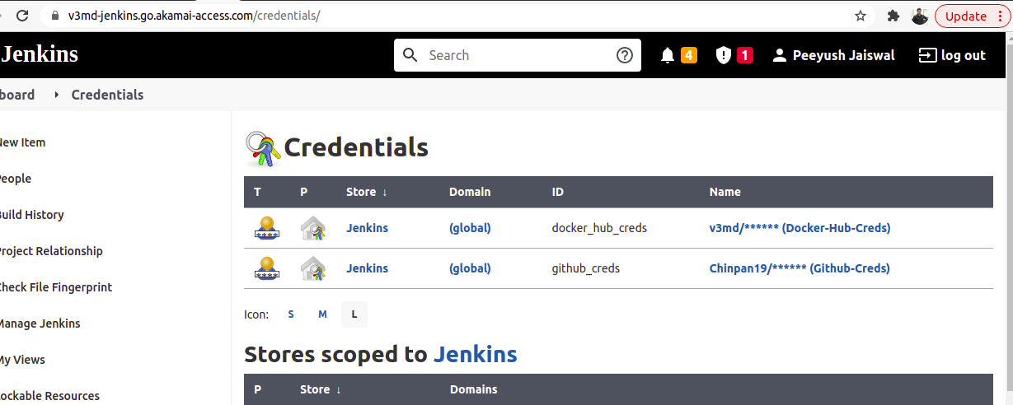

Second, we should create jenkinsfile as below screenshot

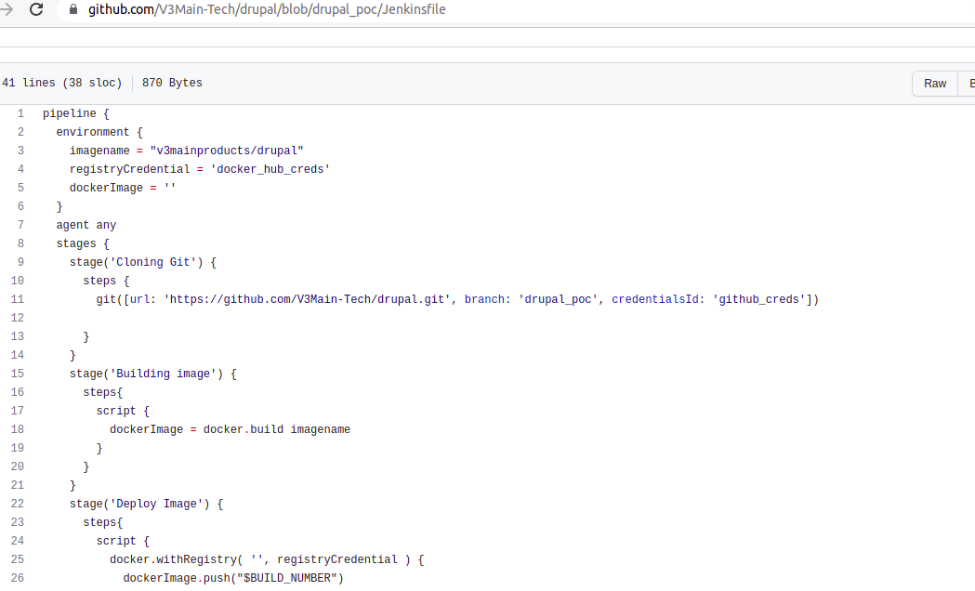

Third, we will have to create pipeline job in Jenkins as per below screens.

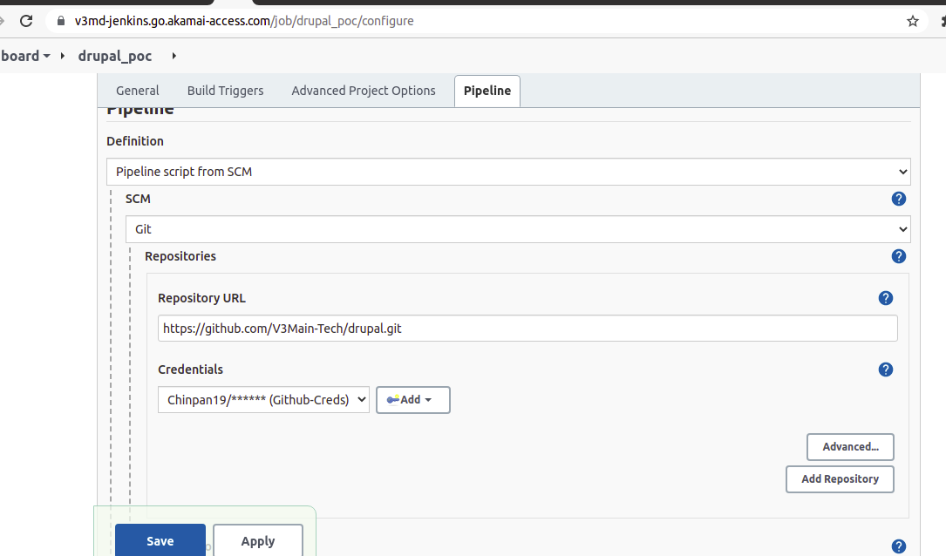

User can see the Jenkins job in dashboard, name as drupal_poc

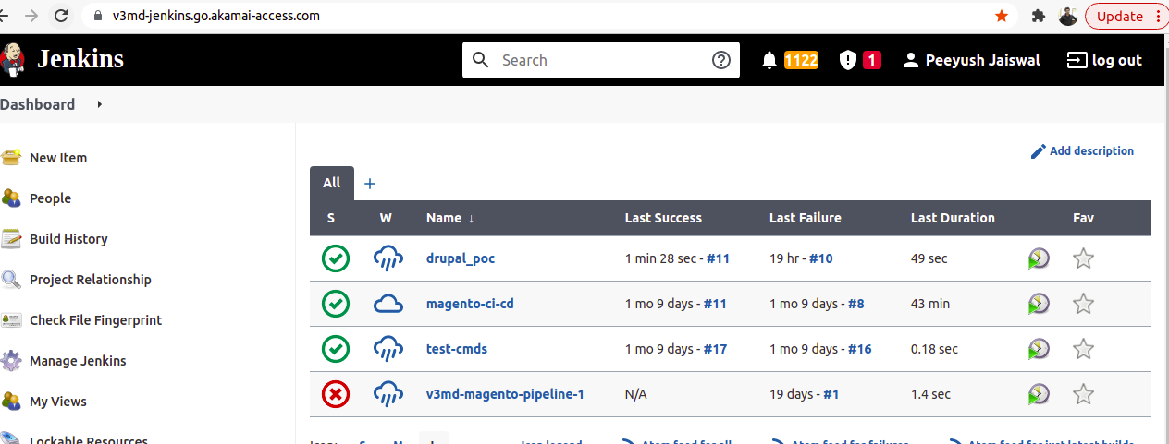

Deploy Docker image to Kubernet Cluster using Jenkins
In this step, we will make connection with kubernet cluster at run time and push the image into cluster but before that below the software should be enable in the server:

Pr e-requisite:
- Kubernetes Cluster
- Kubernetes Client
- Docker
- Jenkins Server
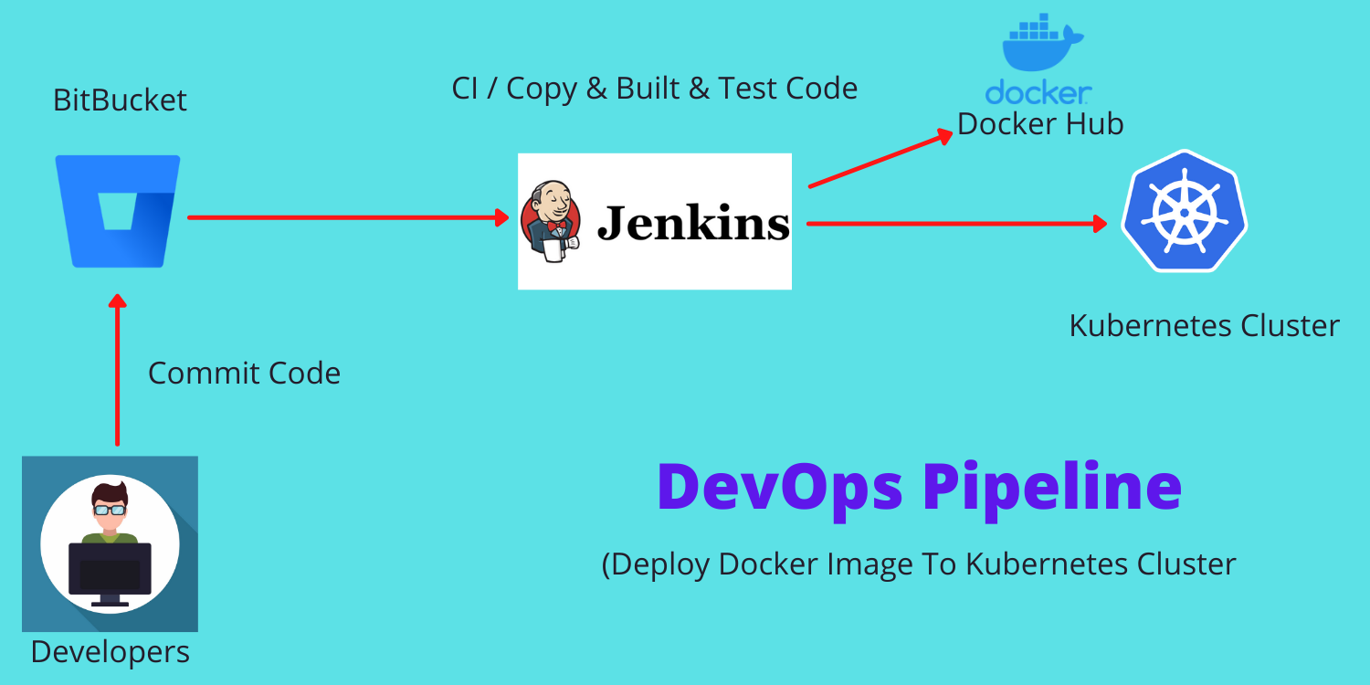
DevOps Kubernetes Diagram

First Jenkins should have installed Kubernet related plugin to make connection between Jenkins and kubernet. Once build is deployed you can verify the pods and services are up and running using below:

Commands:
kubectl get pod

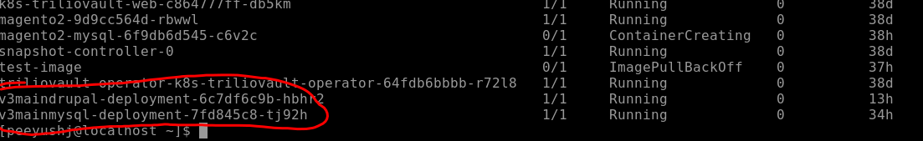
Commands:

kubectl get service

We have 2 service Drupal and MySQL so Admin can deploy the image in kubernet using below command if they want to create at run time. The deployment files (Drupal+MySQL) are deployment.yml and mysql.yml to deploy image in kubernet cluster.

Commands:
Kubectl apply -f deployment.yml

kubectl apply -f mysql.yml

Images needs secret to pull from docker hub and so have to include in both deployment files. Secret can be created by using below command:

Commands:

kubectl create secret docker-registry drupalsecret --docker-server=”registry.hub.docker.com” – docker-username=”<user name>” --docker-password=”<dcoekr password>” --docker- email=”<docker email>”

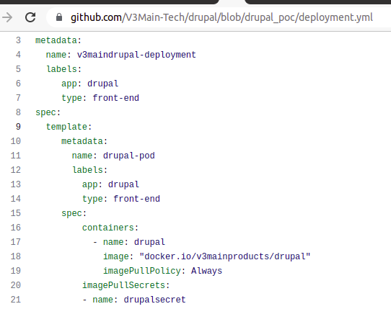

Once build is completed you can verify the host name using get service and see the private IP. Try to copy and open in browser

Application URL:
http://a23b97f844e6c47259f2380bbd919ec8-619031122.us-west-2.elb.amazonaws.com/

After clicking on the above link, please follow the instructions below to install Drupal
- Please ensure you have MySQL details to make the connection.
- Please provide below details in MySQL connections and click Next, this will install drupal core module.
- The next step is to click Continue, this will ask you to populate few details like site name, email, admin user name and password, please provide details and then click continue to complete installation.
- Now Drupal is installed in kubenet cluster.

Source Code and Cred details

GitHub
Drupal 9.3.x code : https://github.com/V3Main-Tech/drupal/tree/9.3.x/

docker code: https://github.com/V3Main-Tech/drupal/tree/drupal_poc/

git hub cred id (Jenkins) : github_creds

Jenkins
https://v3md-jenkins.go.akamai-access.com/job/drupal_poc/

Docker
Docker cred ID (Jenkins) : docker_hub_cred
docker pull v3mainproducts/drupal:latest

MYSQL
Database name: drupal
User name: user
Password : password
DB Host name : mysql

Clear Cache

Drupal clear cache using MySQL:
1). kubectl exec --stdin --tty <mysql pod name> -- /bin/bash
2). mysql -uroot -ppassword
3). use drupal;
4). show tables; : it will show all the table just look for table
which start from cache keyword and clear the data using below commands
- TRUNCATE TABLE cachetags;
- TRUNCATE TABLE cache_bootstrap;
- TRUNCATE TABLE cache_config;
Then try to reload URL it will work.

